TRANSITIONAL SKILLS

LESSON 8-6 MY HIGH SCHOOL PLAN

LEARNING GOALS/OUTCOMES

- Outline local high school graduation course requirements.
- Sort local high school courses and activities into logical areas of interest.
- Create a high school plan.

MATERIALS NEEDED

- Student Handouts:
- High School Course Requirements
- Graduation Time Machine Worksheet
- My High School Course Plan
- Journal Page
- List of electives and activities offered at the local high school. If possible, provide each student with a copy of the high school course selection guide purpose for material
- Clear understanding of the high school graduation requirements for local schools

CLASSROOM ACTIVITIES

- Students use a time machine concept to project their high school accomplishments. Distribute the Graduation Time Machine handout. Provide each student with a copy of the High School Course Requirements handout and a copy of a high school Course Selection Guide. Ask students to imagine they were just walking out of their graduation ceremony and were considering the questions on the worksheet. Have them use the Course Selection Guide to complete the questions on the worksheet independently.

- Students learn about the required courses of high school. Provide each student with a copy of the High School Course Requirements handout and a copy of a high school Course Selection Guide. Review with them the required courses and the elective courses available in the local high school. Show them in the guide where graduation requirements are listed.

- Students learn about the activities of high school. Ask students to review the high school activities listed in the course selection guide. If there are no activities listed, ask students to list all the activities they are aware of at high school. Encourage students to see activities as valuable opportunities to explore interests, develop skills, and create credentials for themselves.

- Students create a context for choosing high school courses and activities. Provide each student with a copy of My High School Course Plan. Tell students that there are several things to think about when they plan their courses for high school. They are: high school graduation requirements, their personal interests, the target skills they seek to develop, and the requirements for entry into their post-secondary goals. Ask students to complete page one and the top of page two, using the Course Selection Guide and other information. This work will help them with their course selection.

- Students identify tentative high school courses and activities for 9th – 12th grade. Encourage students to write the names of courses and activities that they are considering into the appropriate section on page two of the My High School Course Plan handout. As you walk around the class, encourage students to get involved in courses and activities that interest them, develop their skills, enable them to graduate, and that support their future goals.

- Ask students to write responses to the following questions in their Journal Page.
- What excites you the most about going to high school next year?
- What is your biggest concern about going to high school next year?
- How do you feel about the courses available to you at high school? What are courses I will include in my Personalized Pathway Requirement?

STUDENT PRODUCTS

- Completed Graduation Time Machine handout
- Completed My High School Course Plan
- Completed Journal Page

TRANSITIONAL SKILLS

LESSON 8-6 STUDENT HANDOUT

HIGH SCHOOL COURSE REQUIREMENTS

What Courses Do You Need In High School?
What courses will you need to take in high school to succeed in college or in a career? Here’s what’s required to graduate with a Career and College Ready Diploma. Your school counselor may suggest specific courses. Also, students need to meet standard on the Smarter Balanced State assessment and have a High School & Beyond Plan with a Personalized Pathway (PPR).
LANGUAGE ARTS Required: 4 credits
Being able to read well, write fluently, and communicate clearly is absolutely essential for college or for any job. Language arts (English) classes will help you do that and develop an appreciation for literature.

MATHEMATICS Required: 3 credits
A good understanding of math is needed in our high-tech, 21st century world. You should aim to take math every year. Math courses will include Algebra 1,Geometry, Algebra 2/Trigonometry, Pre-calculus, Calculus as well as other rigorous levels of mathematics.

SCIENCE Required: 3 credits 2 Lab Credits
Science is important for any career path, as the study of science teaches you to observe carefully and use logical reasoning to answer questions. Courses include Biology, Chemistry, Physics and other courses.

SOCIAL STUDIES Required: 3 credits
Social studies courses help you learn more about the world around us. These courses could include Washington State History, Civics (Required), World History, World Cultures, US History, Political Science, Economics, Geography, Psychology, as well as other coursework. Washington State History is a requirement that can be met in middle school.

HEALTH AND FITNESS Required: 2 credits
One semester of health and 1.5 semesters of fitness are required for graduation. School districts can develop an Excused Policy for the fitness requirement.

WORLD LANGUAGE or PPR* Required: 2 credits (Both can be PPR)
Most colleges require at least two years of study of a world language. (PPR is the Personalized Pathway Requirement that is based on student’s High School & Beyond Plan.)

ARTS Required: 2 credits (1 can be PPR)
Studying the arts helps you learn to express yourself creatively and find new ways to interpret your surroundings. Arts courses include Art, Music, Photography, Drama, and Dance.

CAREER AND TECHNICAL EDUCATION (CTE) Required: 1 credit

GENERAL ELECTIVES Required: 4 credits

TOTAL REQUIRED CREDITS = 24

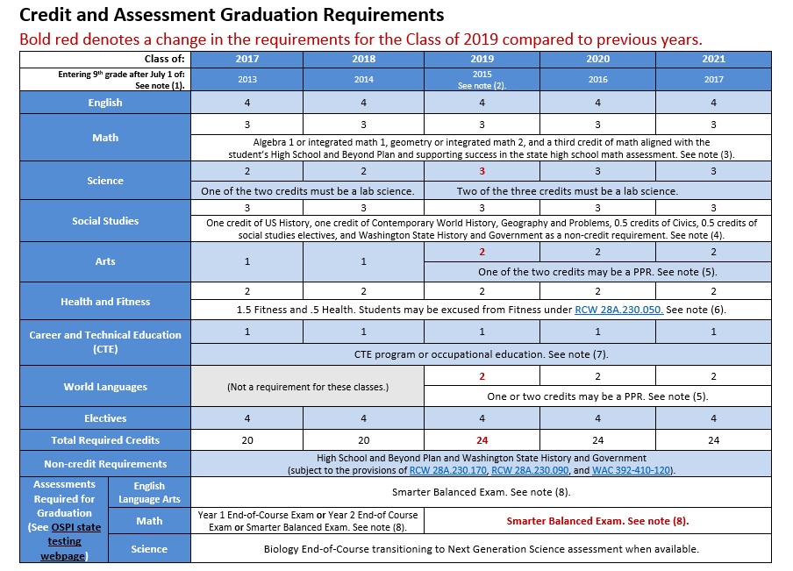

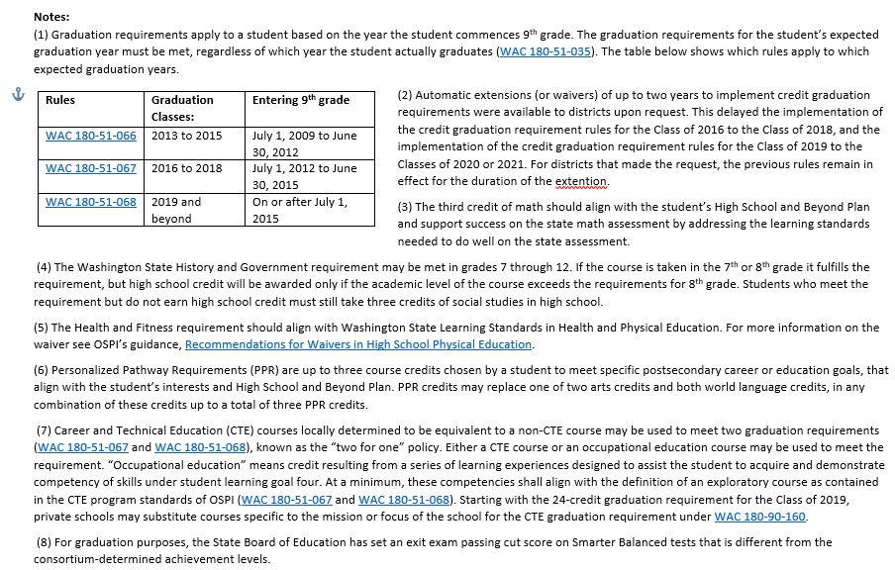

TRANSITIONAL SKILLS

LESSON 8-6 STUDENT HANDOUT

GRADUATION TIME MACHINE WORKSHEET

You just emerged from a time machine and have arrived at your high school graduation. Looking back over your years of high school, what is your story?

WHO WERE YOU AND WHAT DID YOU DO?

Which 6 classes were the most interesting to you?

1:_________________________________ 2:_________________________________

3:_________________________________ 4:_________________________________

5:_________________________________ 6:_________________________________

What school or community activities were most interesting to you?

Activity #1

Activity #2

Activity #3

What were your three greatest academic and/or activity-related accomplishments?

Accomplishment #1

Accomplishment #2

Accomplishment #3

WHAT ARE YOU PLANNING TO DO WITH YOUR LIFE?

What are your top two career goals?

Career Idea #1:

Career Idea #2:

What post-secondary path will you pursue after graduation?

Post-graduate education (such as a medical or law degree)

A 4-year degree path (Bachelor’s Degree) from a 4-year college or university

A 2-year degree path (Associate’s Degree) from a community or technical college

A Career and Technical Education (CTE) certificate path

A specific career path in the military

A job in the workforce

TRANSITIONAL SKILLS

LESSON 8-6 STUDENT HANDOUT

MY HIGH SCHOOL COURSE PLAN

Name:
Subject Area | Your High School’s  Graduation Requirement | Credits you will have by end of 12th grade per your plans | Subject Area | Your High School’s  Graduation Requirement | Credits you will have by end of 12th grade per your plans
English |  |  | Social Studies
Mathematics |  |  | Arts*
Science |  |  | Health & Fitness
World Language or Personalized Pathway Requirement* |  |  | Occupational Ed
Career and  Technical Ed |  |  | General Electives

* Your Personalized Pathway Requirements are related courses that lead to a specific post-high school career or educational outcome chosen by the student based on the student’s interests and High School and Beyond Plan that may include Career and Technical Education, and are intended to provide a focus for the student’s learning.

YOUR PERSONAL INTERESTS

YOUR TARGET SKILLS

YOUR POST-SECONDARY PATHWAY

Four-year college Two-year college CTE (Technical college) Military Workplace

TRANSITIONAL SKILLS

LESSON 8-6 STUDENT HANDOUT

JOURNAL PAGE

DATE:

Lesson 8-7 | MY HIGH SCHOOL PLAN
Q1: What excites you the most about going to high school next year?
Q2: What is your biggest concern about going to high school next year?
Q3: How do you feel about the courses, both required and elective available to you at high school? What are courses I will included in my Personalized Pathway Requirement?

Answers:

