Dyslexia advisory council updates
On April 15-16, 2019, the Dyslexia Advisory Council held its final in person executive work session for School Year 2018-19. On April 15th, the council members began evaluating the proposals submitted under the Request for Qualification and Quotation (RFQQ). The rubric developed for the evaluation was edited by the council members at the March 4th meeting during the executive work session.
The RFQQ generated proposals from around the country and averaged over 100 pages per proposal. The Dyslexia Advisory Council were consummate professionals and spent over 10 hours across April 15-16th evaluating the proposals and thoughtfully providing feedback. After the council members completed the evaluations, a discussion was held highlighting the merits and concerns of the potential screening tool.
The Dyslexia Advisory Council voted on every proposal submitted under the RFQQ. The proposals that were approved by the Dyslexia Advisory Council are being recommended to Superintendent Chris Reykdal on June 1, 2019 for OSPI endorsement.
On September 1, 2019, OSPI will post on its website the OSPI endorsed screening tools along with additional resources to support districts with selecting a tool for their schools. Under local control, districts may select another tool beyond the endorsed list that meets the best practices outlined in Early Screening of Dyslexia Statute:
NEW SECTION. Sec. 2. A new section is added to chapter 28A.320 RCW to read as follows:
(2)(a) School districts must use screening tools and resources that exemplify best practices, as described under section 3 of this act. (b) School districts may use the screening tools and resources identified by the superintendent of public instruction in accordance with section of this act.
NEW SECTION. Sec. 3.A new section is added to chapter 28A.300 RCW to read as follows:
(1) By September 1, 2019, the superintendent of public instruction, after considering recommendations from the dyslexia advisory council convened under section of this act, must identify screening tools and resources that, at a minimum, meet the following best practices to: (a) Satisfy developmental and academic criteria, including considerations of validity and reliability, that indicate typical literacy development or dyslexia, taking into account typical child neurological development; and (b) Identify indicators and areas of weakness that are highly predictive of future reading difficulty, including phonological awareness, phonemic awareness, rapid naming skills, letter sound knowledge, and family history of difficulty with reading and language acquisition.
________________________________________________________________________

Dyslexia advisory council updates
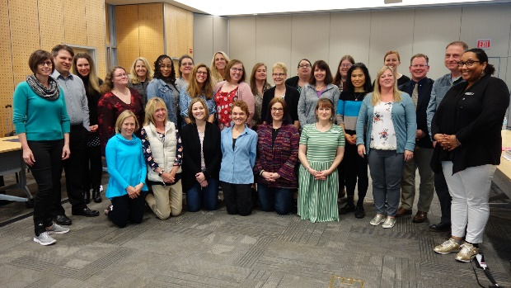
To close out the final convening of School Year 2018-19, Superintendent Chris Reykdal came and visited with the Dyslexia Advisory Council. Superintendent Reykdal talked about potential next steps for implementing the Early Screening of Dyslexia statute and graciously answered a variety of questions from council members about the state of education in Washington. At the end we took a class picture; we hope you enjoy it!

________________________________________________________________________
Upcoming Convenings for School Year 2019-20:
The Dyslexia Advisory Council will continue to meet during school year 2019-20 on the following dates to develop implementation tools and resources for schools, districts, and families. More details on the Dyslexia Advisory Council convenings will be posted when OSPI transitions to its new website in July.
  - Public Meeting with Executive Work Session: Monday and Tuesday, October 21-22, 2019
  - Executive Work Session: Thursday, December 5, 2019 from 8AM-1PM via Zoom Online Meeting System
  - Public Meeting with Executive Work Session: Saturday, February 1, 2020 from 10AM-4PM via Zoom Online Meeting System
  - Executive Work Session: Monday and Tuesday, April 20-21, 2020
________________________________________________________________________
What is Rapid Automatized Naming (RAN)? Many of you have asked what is RAN or is it letter-sound identification? In this wonderful article from Understood, the author provides an overview of the RAN, why it is not only letter-sound identification, and why it should be administered with other skill screeners. For more information, please visit: https://www.understood.org/en/school-learning/evaluations/types-of-tests/rapid-automatized-naming-tests-what-you-need-to-know.
________________________________________________________________________

OSPI Online Updates
OSPI will be providing live updates via the Zoom Online Meeting System on the implementation of E2SSB 6162-Early Screening of Dyslexia during the next school year. Registration for the Zoom Online Updates will be available ten days before each update.
Tuesday, September 10, 2019 at 4PM
Wednesday, December 11, 2019 at 4PM
Tuesday, May 5, 2020 at 4PM
________________________________________________________________________
Please note the updates will be taking a summer break and will resume with the release of the OSPI approved screeners at the beginning of the September. Have a wonderful summer!

