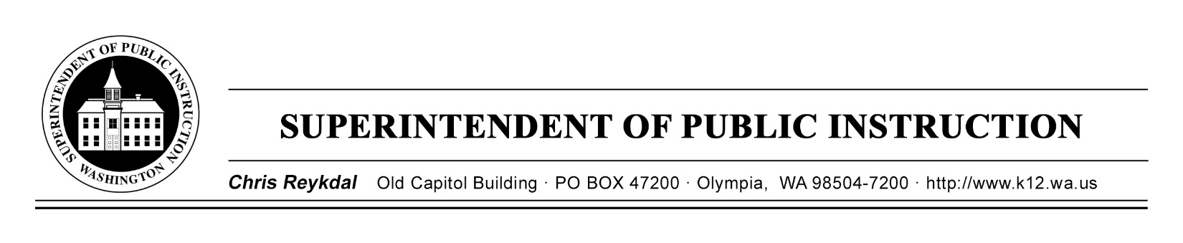
Dyslexia Advisory Council | September 24, 2018 | Sea -Tac Conference Center
E2SSB 6162
Time | Focus | Resources | Notes
9 AM | Coffee and Sign In
9:30 AM | Welcome and Introductions
 | Expectations of the Day
 | What is Your Why?
 | Dyslexia Advisory Council Outcomes | E2SSB 6162(B)*
 | The State of the State | State District Map (B)
12 PM | Working Lunch-Review Dyslexia Guides
 | Understanding WA State Literacy | ELA Standards (B)  ELPS (B)  ELA Menu Excerpt (B)  ELA Pathways (B)
 | Understanding WA State Assessment Requirements in K-2 | GOLD (B)  2nd Grade Fluency (B)  ELPA 21 (B)
2:30 PM | Break
 | Continued Understanding WA State Assessments in K-2
 | Extended Learning for Tuesday
4 PM | Good Bye

