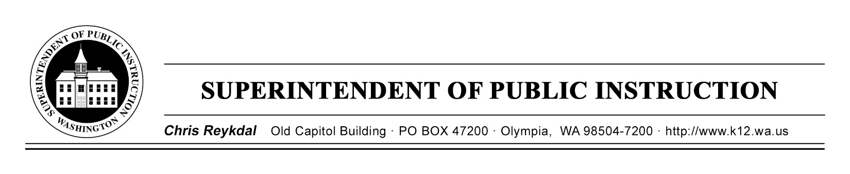
Dyslexia Advisory Council | November 19, 2018 | Sea -Tac Conference Center
E2SSB 6162

Time | Focus | Resources | Notes
9AM | Coffee and Sign In
9:30 AM | Welcome
Goals for the Day
Ah Ah’s and Wonderings
Since We Last Met…
Highlights of International Dyslexia Association Conference
 | The Fidelity of Screening Throughout the Year | E2SSB 6162 (B)
12 PM | Working Lunch-Travel Reimbursements | Travel Reimbursements
12:45 PM | Consensus on Skills Identified in Statute | E2SSB 6162 (B)
Communication
Digital Collaboration
2:30 PM | Break
2:45 PM | Plan for Request for Information  Upcoming Meetings
 | Next Steps
4 PM | Good Bye and Safe Travels

